LAPORAN PROJECT UTS WEB FRAMEWORK



OLEH :

|  |  |
| --- | --- |
| NAMA : | RERI AYU RESTAMI |
| NIM : | TI17200044 |
| PRODI : | TEKNIK INFORMATIKA B |
|  |  |

YAYASAN LOMBOK MIRAH

SEKOLAH TINGGI MANAJEMEN DAN KOMPUTER

LOMBOK

NORMALISASI

**1 NF**

|  |  |  |  |  |  |  |  |  |  |  |  |
| --- | --- | --- | --- | --- | --- | --- | --- | --- | --- | --- | --- |
| NO | NAMA | KONTAK WHATSAPP | BAGIAN | JENIS  KEBUTUHAN  TEKNIS | KEBUTUHAN  TENTANG | DESKRIPSI  KEBUTUHAN | DESKRIPSI FOTO/  VIDEO | URGENSI | KATEGORI | PROGRESS | PIC |

**2 NF**

PROFILE

|  |  |  |  |  |  |  |  |  |  |  |
| --- | --- | --- | --- | --- | --- | --- | --- | --- | --- | --- |
| NO | NAMA | KONTAK  WHARSAAP | JENIS  KEBUTUHAN  TEKNIS | KEBUTUHAN  TENTANG | DESKRIPSI  KEBUTUHAN | DESKRIPSI  FOTO/  VIDEO | URGENSI | KATEGORI | PROGRESS | PIC |

BAGIAN

|  |
| --- |
| BAGIAN |

**3 NF**

PROFIL

|  |  |  |  |  |  |  |  |  |
| --- | --- | --- | --- | --- | --- | --- | --- | --- |
| NO | NAMA | KONTAK  WHATSAPP | KEBUTUHAN  TENTANG | DESKRIPSI  KEBUTUHAN | DESKRIPSI  FOTO/  VIDEO | KATEGORI | PROGRESS | PIC |

BAGIAN

|  |
| --- |
| BAGIAN |

Jenis_keb

|  |
| --- |
| JENIS  KEBUTUHAN  TEKNIS |

KELAS DIAGRAM

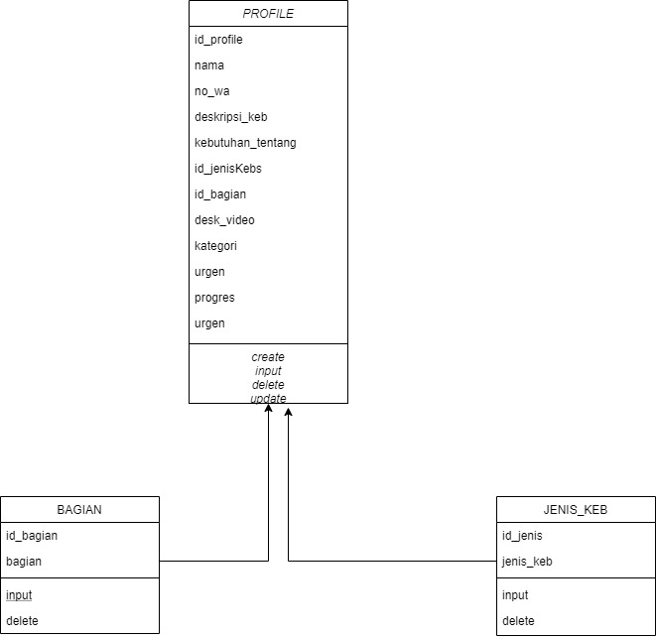

DATABASES

TABEL PROFILE

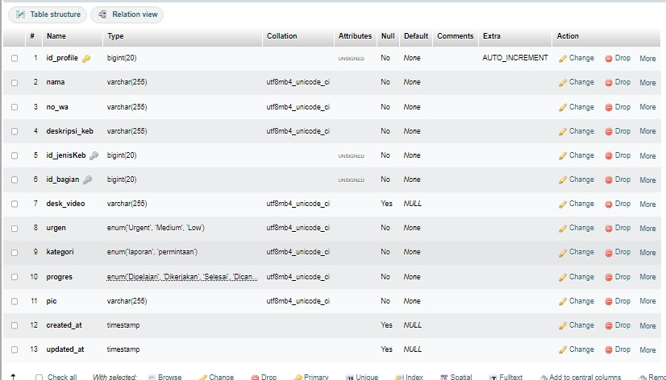

TABEL BAGIAN

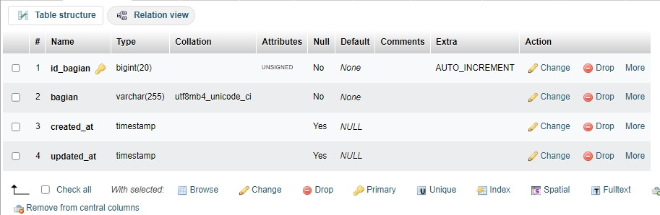

TABEL JENIS_KEB

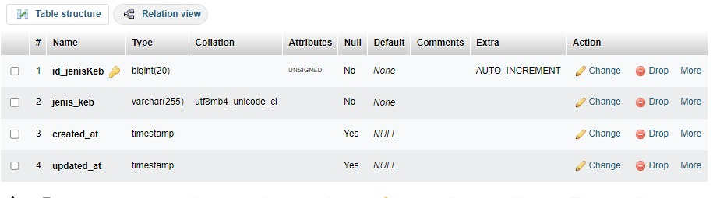

TAMPILAN

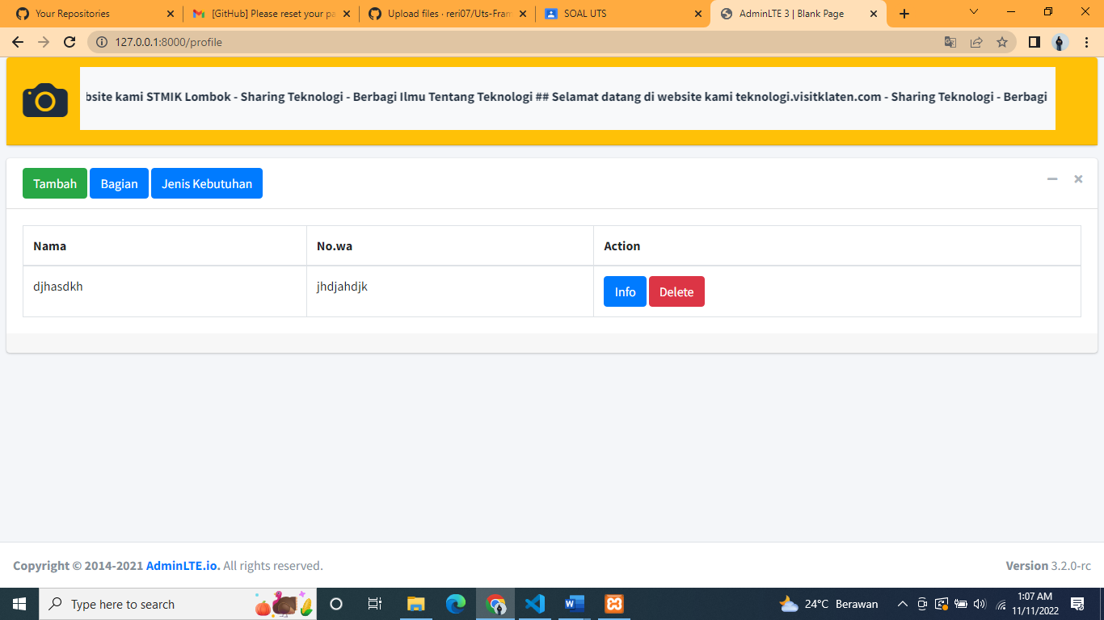

TAMBAH

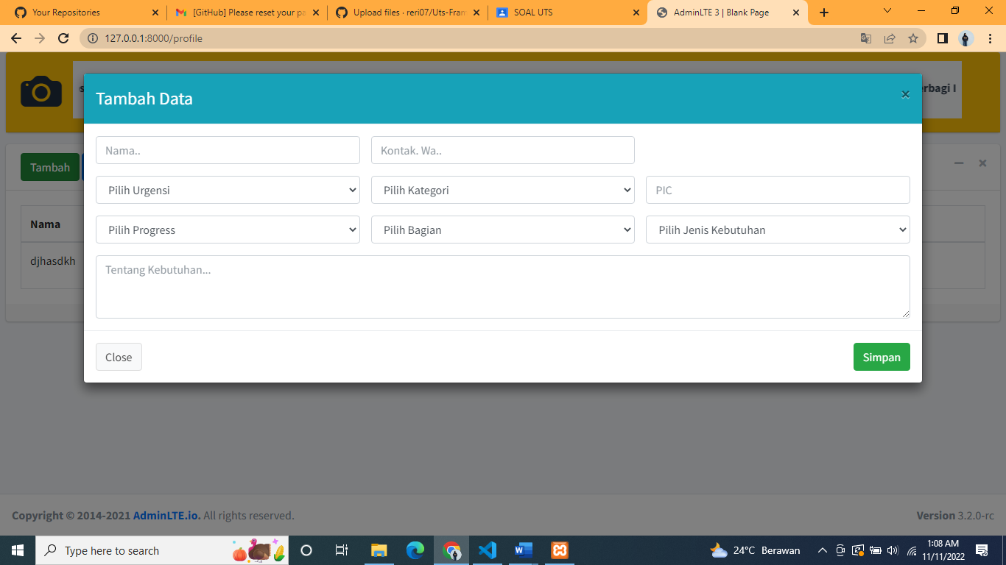

BAGIAN

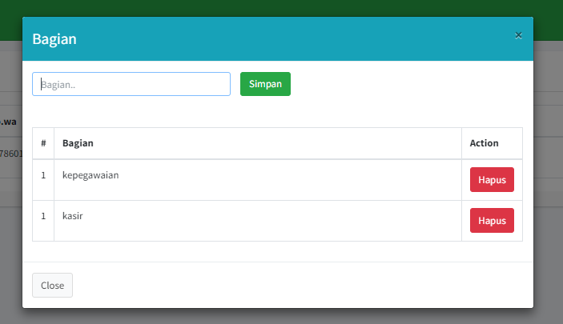

JENIS KEBUTUHAN

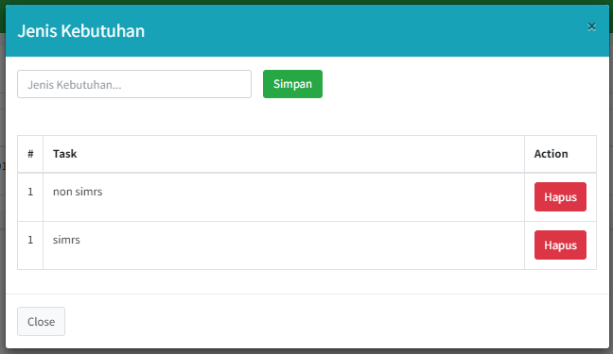

LINK GITHUB

https://github.com/RiskaIndahCahyanti4/UTS_FRAMWORK.git